**How run server**

**The First step**

**You should install library (python -m venv venv) in new terminal**

**After install we will activate it by write this (.\.venv\Scripts\activate.bat)**

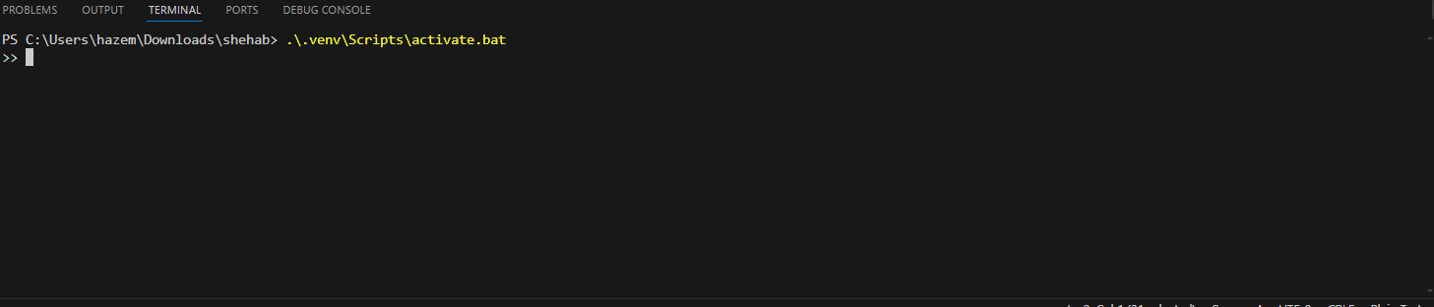

**The Second step**

**We will write cd shehab**

**After this write cd shehab agine**

**The Third step**

**After this we will write cd src**

**The four step**

**We will write (pip install -r requirements.txt)**

**The five step**

**After we install -r requirements.txt**

**We will write (python manage.py runserver) in src**

**After this the server will Run**

